Jenkins installation

**Install – Jenkins**

* [Refer Here](https://www.jenkins.io/doc/book/installing/linux/) for installing jenkins on linux
* Ubuntu steps: [Refer Here](https://www.jenkins.io/doc/book/installing/linux/#debianubuntu)

sudo apt update

sudo apt install openjdk-17-jdk -y

curl -fsSL https://pkg.jenkins.io/debian-stable/jenkins.io-2023.key | sudo tee \

/usr/share/keyrings/jenkins-keyring.asc > /dev/null

echo deb [signed-by=/usr/share/keyrings/jenkins-keyring.asc] \

https://pkg.jenkins.io/debian-stable binary/ | sudo tee \

/etc/apt/sources.list.d/jenkins.list > /dev/null

sudo apt update

sudo apt install jenkins -y

* Navigate to http://<public-ip>:8080  
  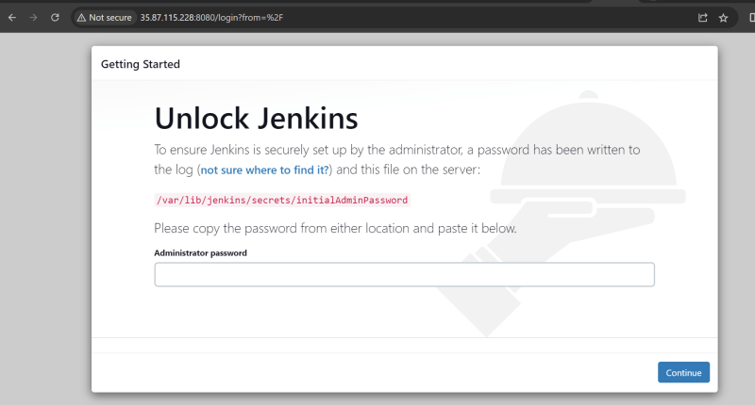
* findout the initial Admin password

sudo cat /var/lib/jenkins/secrets/initialAdminPassword

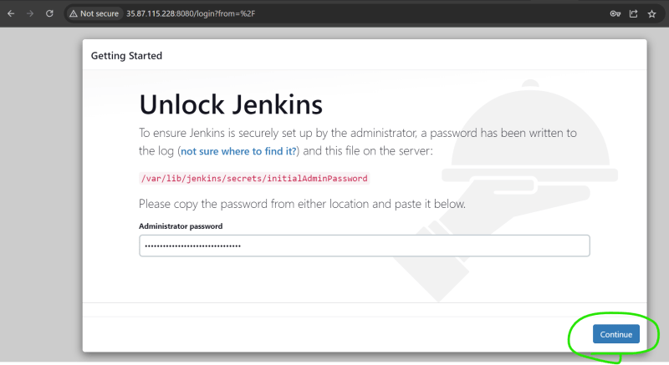  
* Now install suggested plugins  
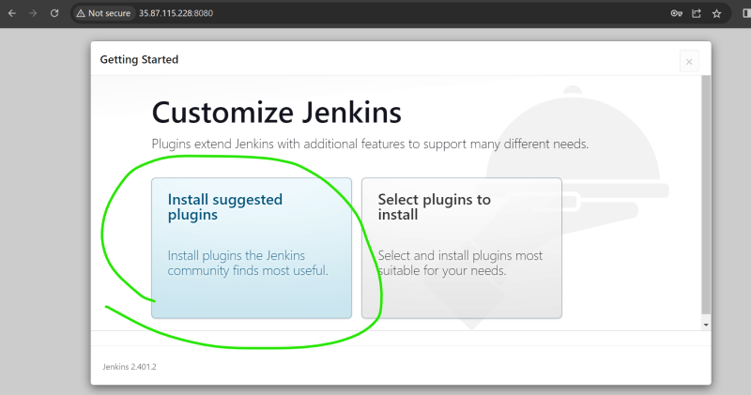  
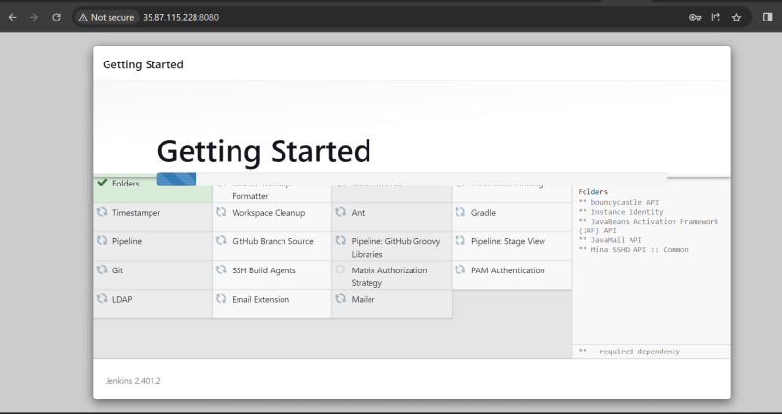  
* Create a new admin user  
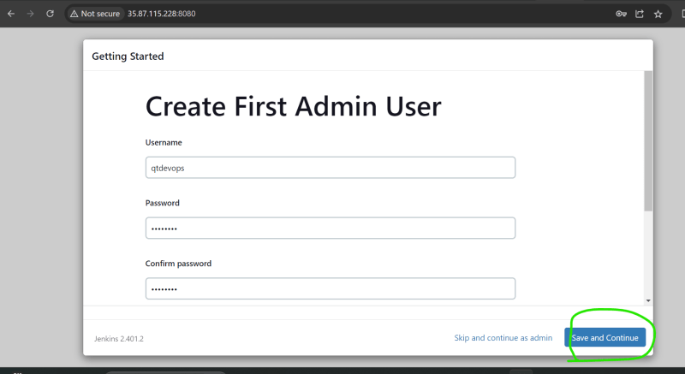  
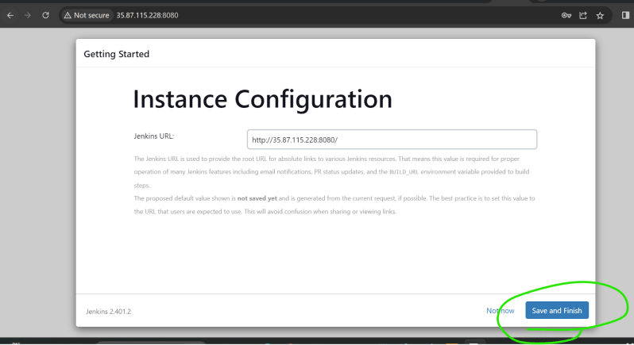  
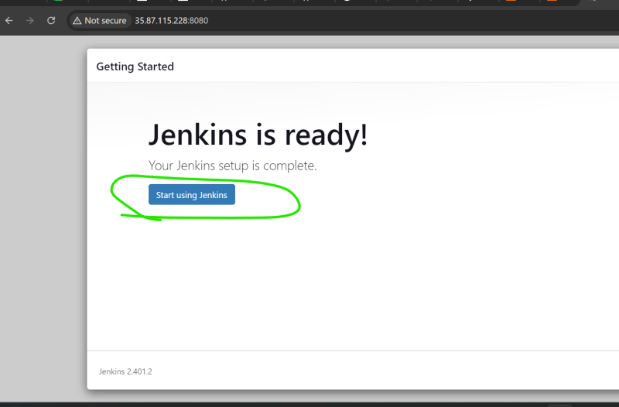  
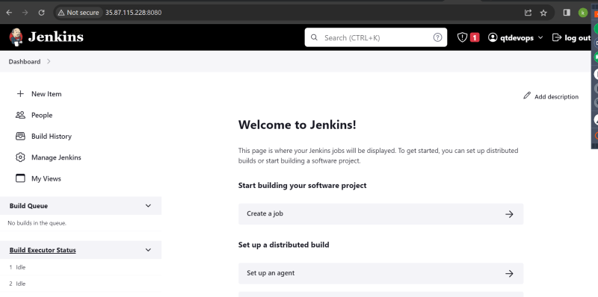

* after completion of configuration give sudoers permissions.

`Sudo vi /etc/sudoers`

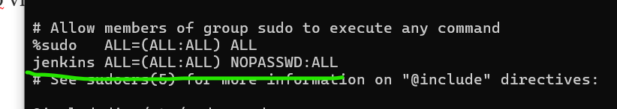

Using Jenkins:

exercise : ping-google

* select new item

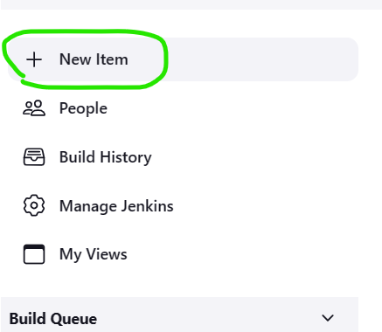

* enter name and select freestyle

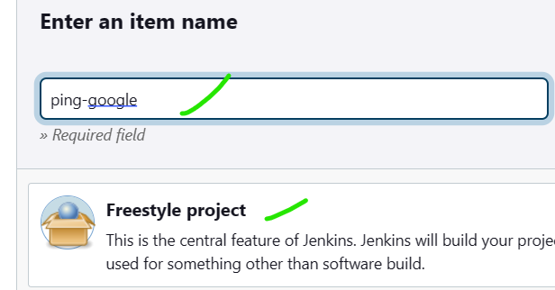

* click on next
* if you want to execute periodically
* select build periodically and enter time from cornjob guru

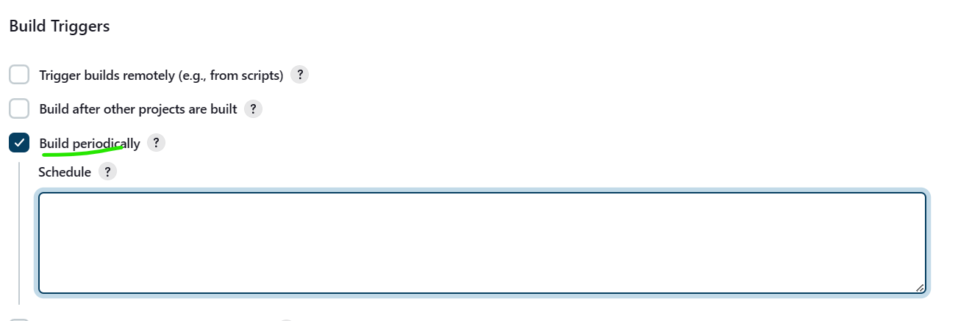

* in Build Steps select Execute Shell

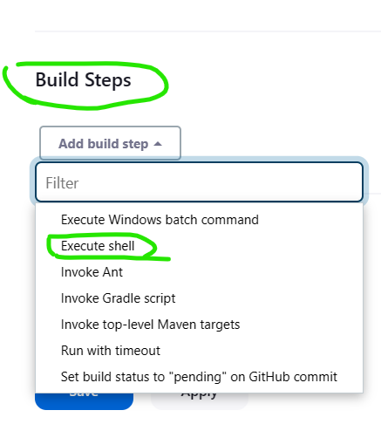

* write your shell script and select save

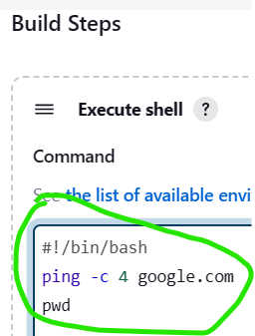

* now click build now

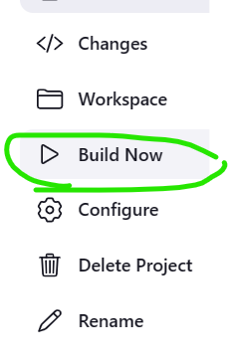

* select the build

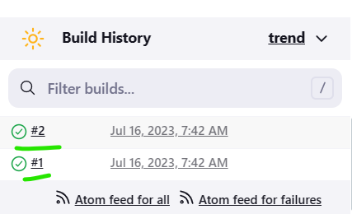

* output

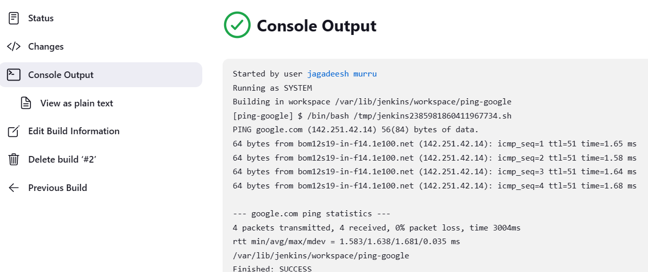

Spring Petclinic:

* requirements to build
  + - java jdk 17
    - maven 3.9
* git clone <https://github.com/dummyrepos/spring-petclinic-1.git>
* results path: **/spring-petclinic-*.jar
* artifacts path:**/target/surefire-reports/TEST-*.xml

Game of life:

* git clone https://github.com/dummyrepos/game-of-life-july23.git
  + requirements to build
    - java 8
    - maven
* results path:  **/surefire-reports/TEST-*.xml
* artifacts path: **/gameoflife.war

Nopcommerce:

* git clone https://github.com/dummyrepos/nopCommerce-july23.git
* requirements to build
  + dotnet 7

Maven 3.9 insatllation:

cd /tmp

wget https://dlcdn.apache.org/maven/maven-3/3.9.3/binaries/apache-maven-3.9.3-bin.tar.gz

sudo mkdir /usr/share/maven3.9

sudo tar -xvzf apache-maven-3.9.3-bin.tar.gz -C /usr/share/maven3.9

# add /usr/share/maven3.9/apache-maven-3.9.3/bin to the PATH variable

# add to ~/.bashrc or /etc/environment

mvn –version